LEET CODE (JAVA)

1 . Given an array of integers nums and an integer target, return indices of the two numbers such that they add up to target.
You may assume that each input would have exactly one solution, and you may not use the same element twice.
You can return the answer in any order.
Example 1:
Input: nums = [2,7,11,15], target = 9
Output: [0,1]
Explanation: Because nums[0] + nums[1] == 9, we return [0, 1].
Example 2:
Input: nums = [3,2,4], target = 6
Output: [1,2]
Example 3:
Input: nums = [3,3], target = 6
Output: [0,1]
Constraints:
- 2 <= nums.length <= 10⁴
- -10⁹ <= nums[i] <= 10⁹
- -10⁹ <= target <= 10⁹
- Only one valid answer exists.

2. Add Two Numbers
You are given two non-empty linked lists representing two non-negative integers. The digits are stored in reverse order, and each of their nodes contains a single digit. Add the two numbers and return the sum as a linked list.
You may assume the two numbers do not contain any leading zero, except the number 0 itself.
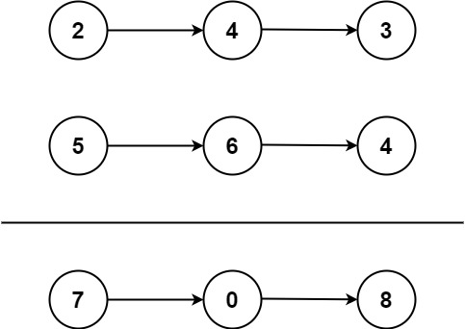
Input: l1 = [2,4,3], l2 = [5,6,4]
Output: [7,0,8]
Explanation: 342 + 465 = 807.
Example 2:
Input: l1 = [0], l2 = [0]
Output: [0]
Example 3:
Input: l1 = [9,9,9,9,9,9,9], l2 = [9,9,9,9]
Output: [8,9,9,9,0,0,0,1]

Constraints:
- The number of nodes in each linked list is in the range [1, 100].
- 0 <= Node.val <= 9
- It is guaranteed that the list represents a number that does not have leading zeros.

3. Reverse Integer
Given a signed 32-bit integer x, return x with its digits reversed. If reversing x causes the value to go outside the signed 32-bit integer range [-2³¹, 2³¹ - 1], then return 0.
Assume the environment does not allow you to store 64-bit integers (signed or unsigned).

Example 1:
Input: x = 123
Output: 321
Example 2:
Input: x = -123
Output: -321
Example 3:
Input: x = 120
Output: 21

Constraints:
- -2³¹ <= x <= 2³¹ – 1

4 . Given an integer x, return true if x is a palindrome, and false otherwise.
Example 1:
Input: x = 121
Output: true
Explanation: 121 reads as 121 from left to right and from right to left.
Example 2:
Input: x = -121
Output: false
Explanation: From left to right, it reads -121. From right to left, it becomes 121-. Therefore it is not a palindrome.
Example 3:
Input: x = 10
Output: false
Explanation: Reads 01 from right to left. Therefore it is not a palindrome.
Constraints:
- -2³¹ <= x <= 2³¹ – 1
5 . Longest Palindromic Substring
Given a string s, return the longest palindromic substring in s.
Example 1:
Input: s = "babad"
Output: "bab"
Explanation: "aba" is also a valid answer.
Example 2:
Input: s = "cbbd"
Output: "bb"

Constraints:
- 1 <= s.length <= 1000
- s consist of only digits and English letters.

